|  |  |  |  |
| --- | --- | --- | --- |
| 1 | | 148,067.2857142857 | |
| NUMERO DE FRONTERAS | | ENERGIA AGREGADA | |
|  | | | |
| SI | | 26-11-2019 | |
| CONTRATO | | VENCIMIENTO CONTRATO | |
|  | | | |
| 425,724,484 | 123 | | 15,642,175 |
| INGRESO 2019 | DÍAS CERTIFICADOS 2019 | | ENERGIA RESPALDADA 2019 |
|  | | | |
| 495,353,187 | 152 | | 17,603,378 |
| INGRESO 2020 | DÍAS CERTIFICADOS 2020 | | ENERGIA RESPALDADA 2020 |
|  | | | |
| 469,775,444 | 139 | | 19,521,717 |
| INGRESO 2021 | DÍAS CERTIFICADOS 2021 | | ENERGIA RESPALDADA 2021 |

|  |
| --- |
| **HILANDERIAS UNIVERSAL**  USUARIO |

|  |
| --- |
| **Mateo Porras**  Ejecutivo de cuenta |

|  |
| --- |
| **Matias Ohlgisser / Gerente General / matias@unihilo.com.co**  PUNTO FOCAL |

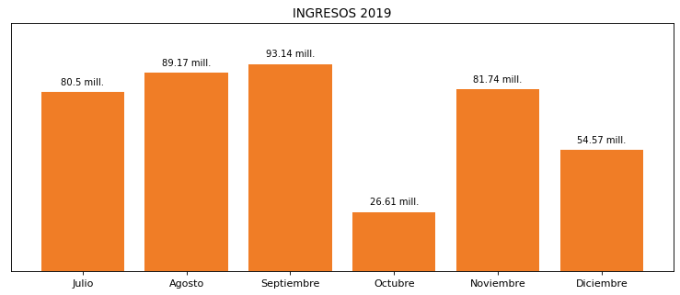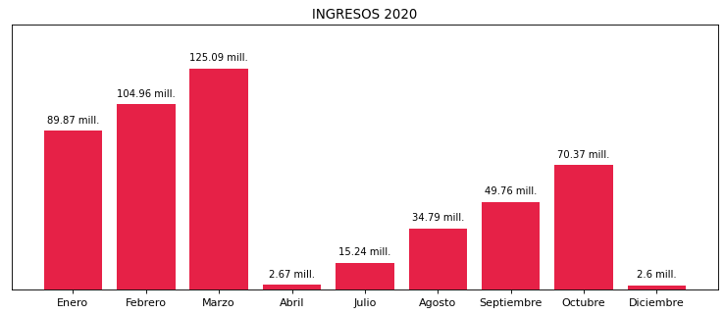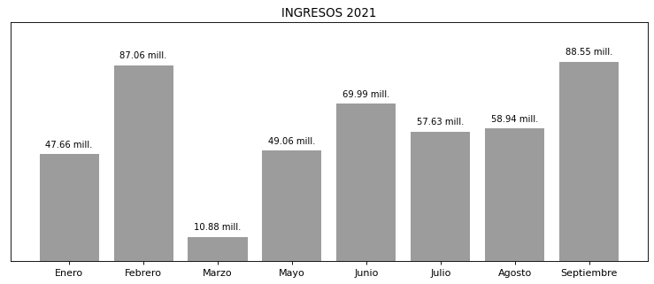

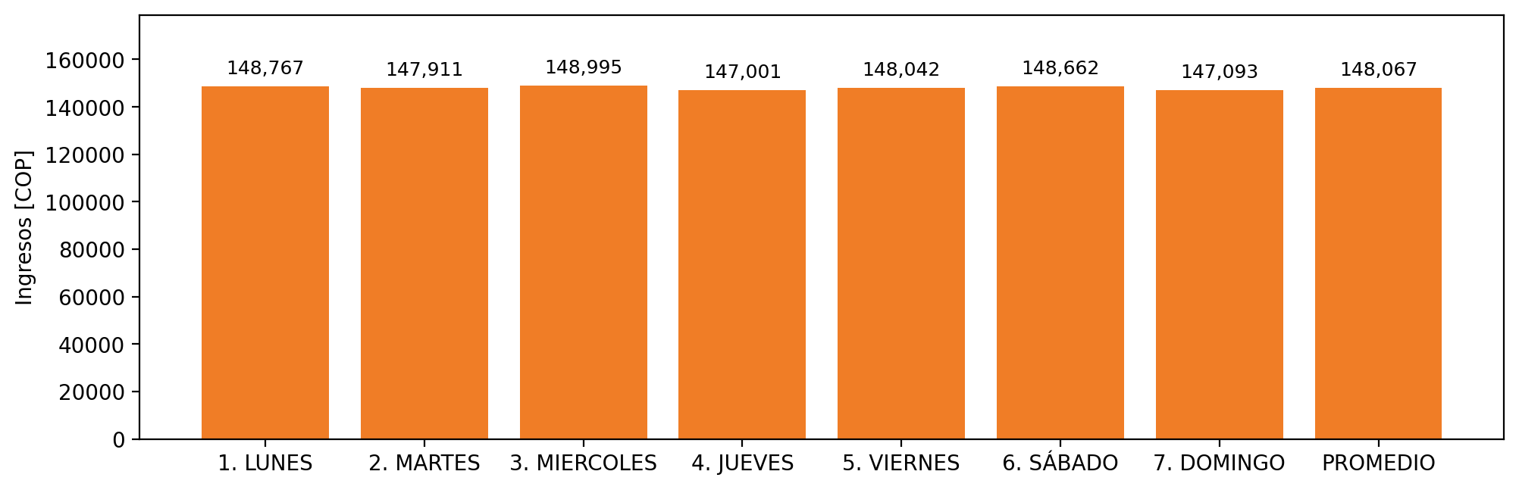

|  |  |  |  |  |  |  |  |  |  |  |
| --- | --- | --- | --- | --- | --- | --- | --- | --- | --- | --- |
| **FRONTERA** | **COD SIC** | **PREDIO** | **FRT DDV** | **TIPO DDV** | **PROMEDIO** | **PRÓXIMA ACTUALIZACIÓN** | **MARGEN DE ERROR** | **ÚLTIMA PRUEBA DDV** | **DÍAS PARTICIPACIÓN** | **FECHA REFERENCIA PRÓXIMA PRUEBA DDV** |
| HILANDERIAS UNIVERSAL S.A | Frt00675 | Prd01341 | Frt33264 | LBC | 148,067 | 2022-02-10 | 1,51 | 2021-06-30 | 58.0 | 2021-12-07 |